GROUND LOADS Tutorial

The study case is relative to a UAV composed of 2 main landing gears (MLG1 and MLG2) and one nose landing gear (NLG). The maximum takeoff weight, the maximum landing weight and some geometrical data are provided in the pictures here after.

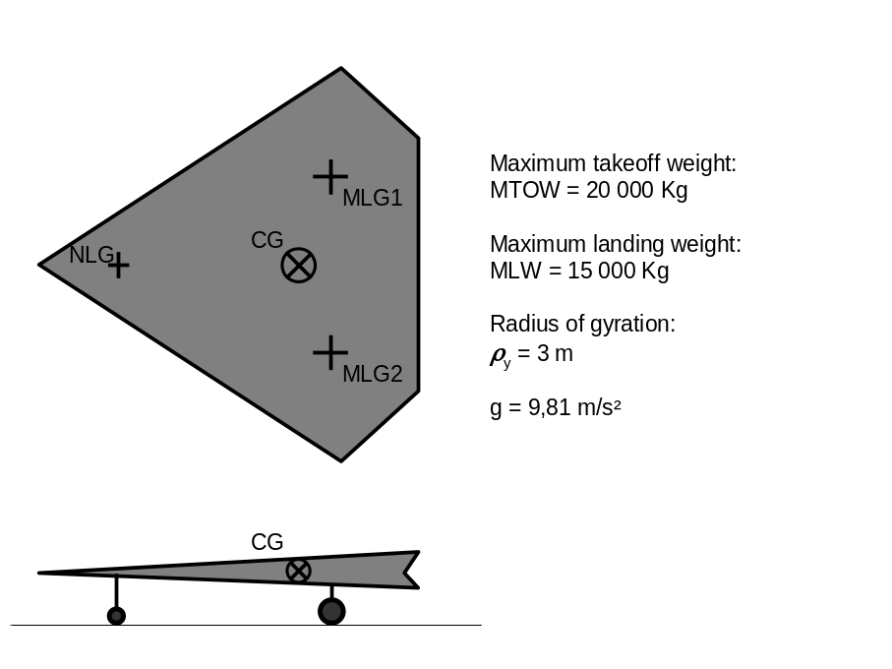

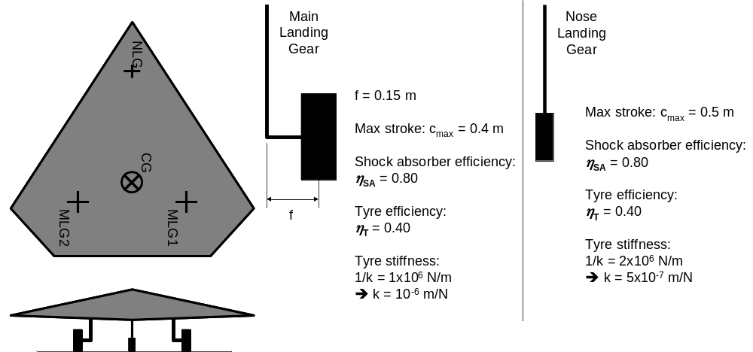

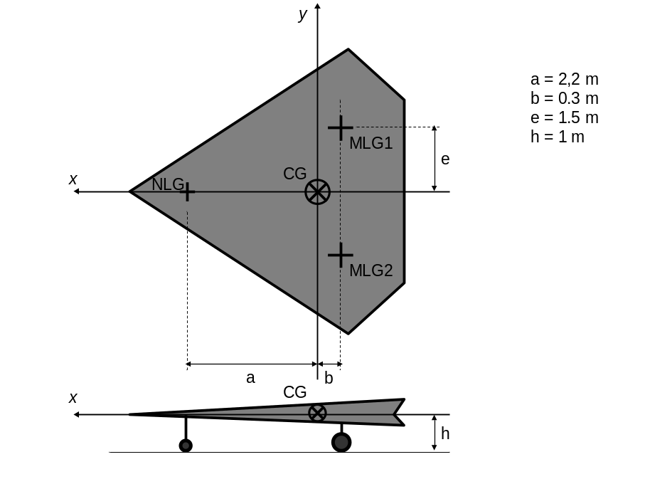

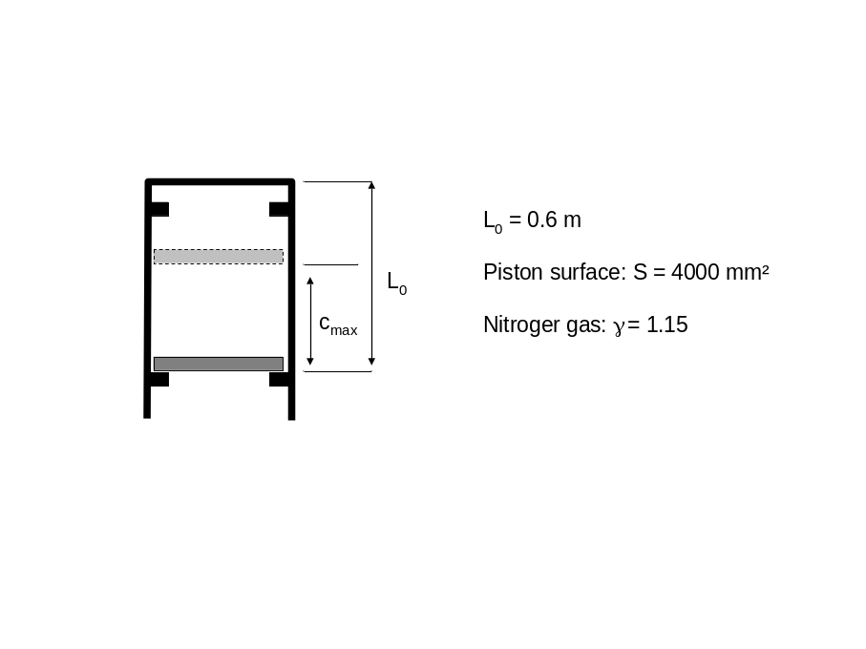

GENERALITIES

1/ Determine the load on each landing gear when the aircraft is at MTOW, on static position.

The requirements for civil transport aircraft generally define 2 design sink speeds: Vz = 10 ft/s (3.05 m/s) at MLW, and Vz = 6 ft/s (1.83 m/s) at MTOW. The same sink speeds are considered for the present UAV.

The loads are calculated through moment balances as shown.
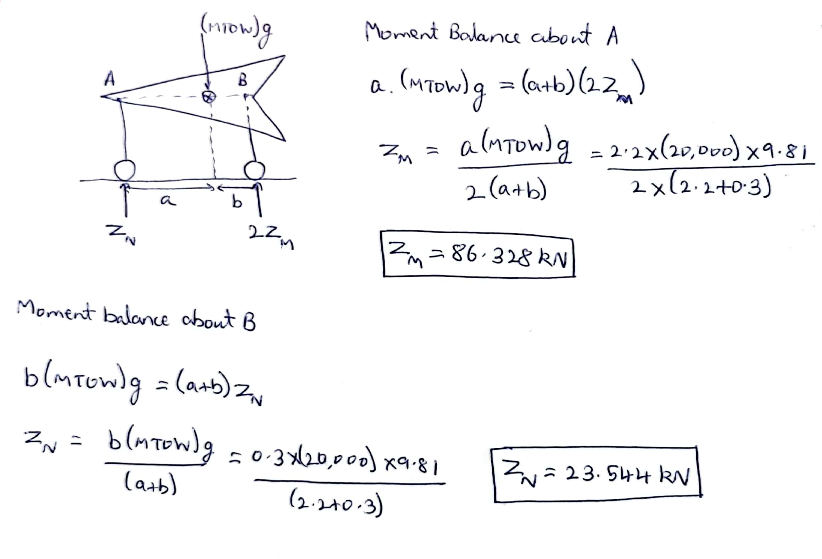

Z_{M}^{static} = 86.328 kN
Z_{N}^{static} = 23.544 kN

2/ Determine the sizing energy to be absorbed by one of the MLG. Same question for the NLG.

In order to determine the sizing scenario for the Main Landing Gear, we calculate the kinetic energy to be absorbed with MLW as well as MTOW.

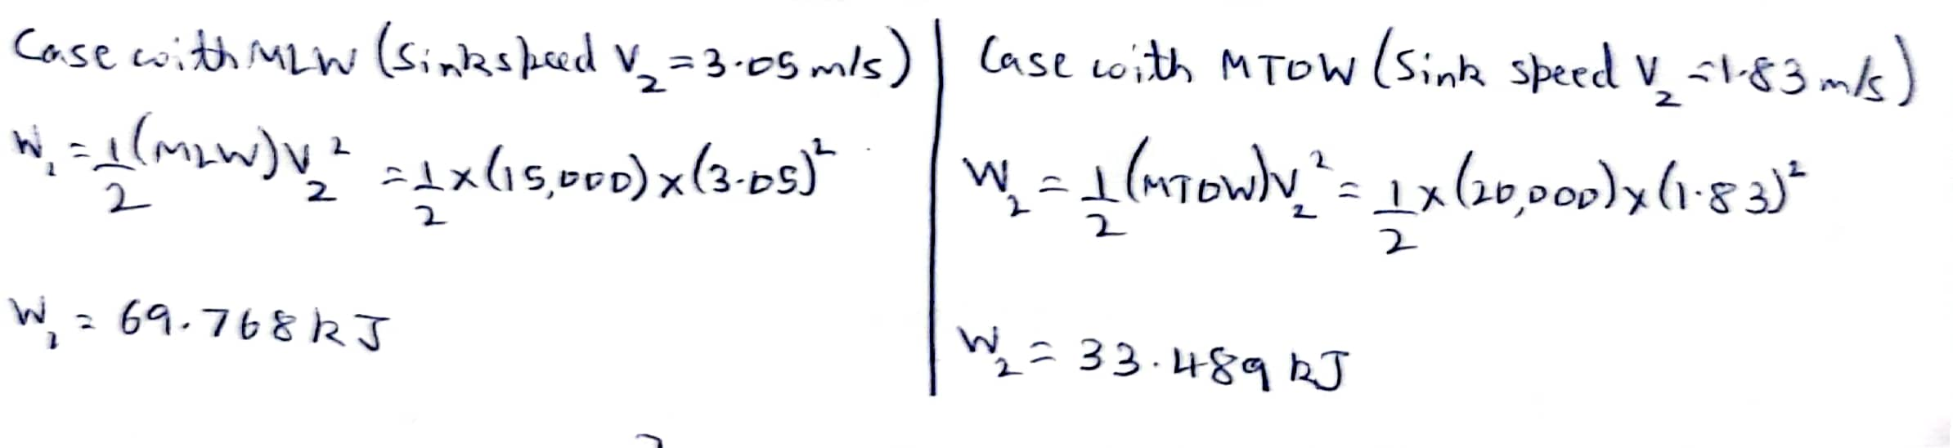

Since W₁ > W₂, for the MLG, the sizing scenario is when the aircraft is landing with MLW mass with a 2-point landing configuration.
In the case of 2-point landing, the aircraft approaches the runway at an angle. Due to this, when the MLGs make contact, the vertical reaction creates a pitching moment about the CG of the aircraft. Therefore, some of the kinetic energy to be absorbed transforms into rotational energy. In this situation, instead of MLW, we consider the reduced mass to calculate the kinetic energy given by the equation.

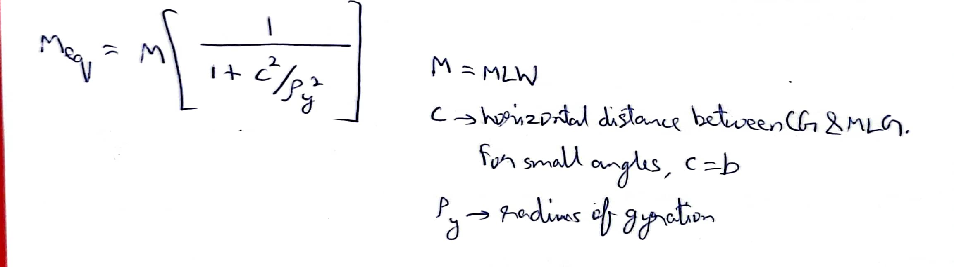

For the Nose Landing Gear, the sizing scenario is when the aircraft is landing with MLW mass with a 3-point landing configuration.
In this case, since all 3 landing gears are making contact at the same time, we have to first calculate how much of the load is being taken by the NLG. We do that through force and moment balances. In order to reflect the sizing scenario, a 0.25 rolling friction coefficient acts on the wheels. This case corresponds to the situation when the tire is deflated and there are no brakes applied.
The final load taken by the NLG is based on the equation shown.

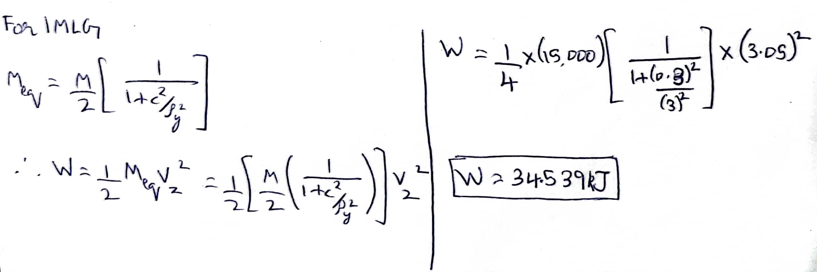
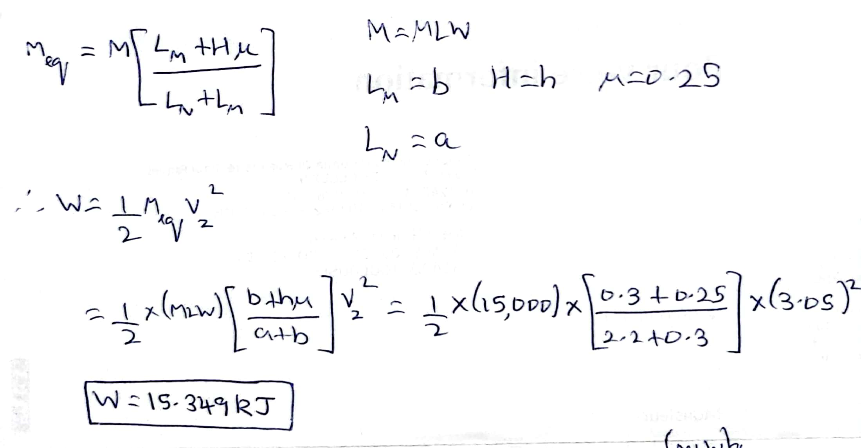

W_{MLG} = 34.539 kJ
W_{NLG} = 15.349 kJ

LEVEL, 2-point landing

3/ Determine the maximum vertical reaction on the MLG in level, 2-point landing condition.

The Main Landing Gear absorbs the energy through the shock absorber as well as tire. The shock absorber is most commonly an oleo pneumatic type while the tire acts like a simple spring. The energy taken up by both the components is related to the maximum vertical reaction through the efficiencies as shown below.

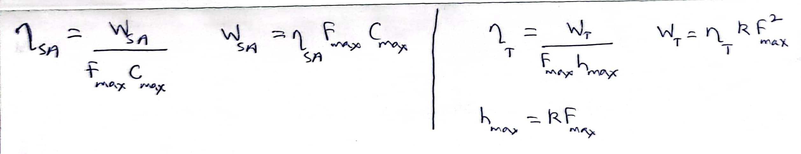

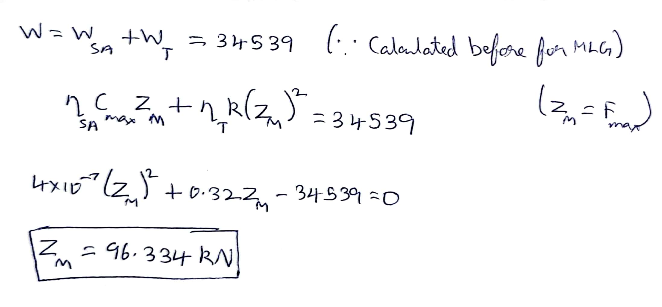
Z_{MLG}^{2-point} = 96.334 kN

4/ Determine the maximum nitrogen pressure (at Zmax) and the initial nitrogen pressure in the shock absorber.

The nitrogen gas is compressed adiabatically inside the shock absorber (since it is a very sudden compression).

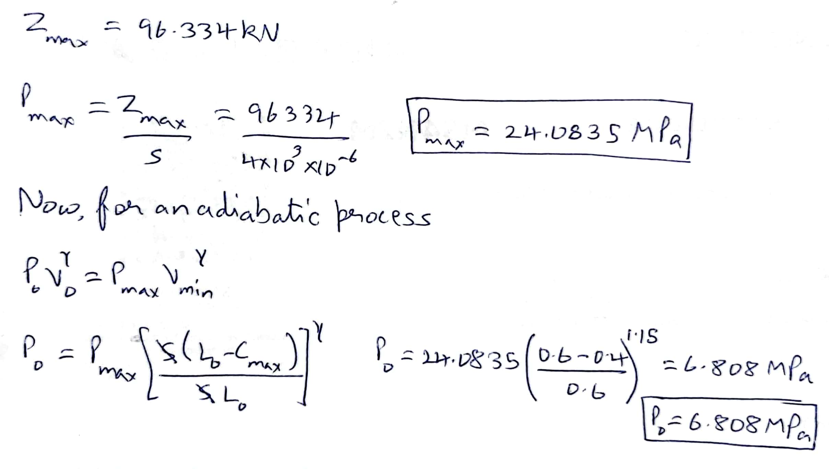
P_{max} = 24.0835 MPa P_{initial} = 6.808 MPa

5/ Determine the loads on the MLG1 and MLG2 during a drift landing (see here after).

During drift landing, the aircraft experiences lateral friction loads right after contact. The friction coefficients are taken as 0.8 and 0.6 on the load acting on the front wheel of the drift direction (inward) and back wheel of the wheel direction (outward) respectively. The vertical load is taken to be half the maximum load.

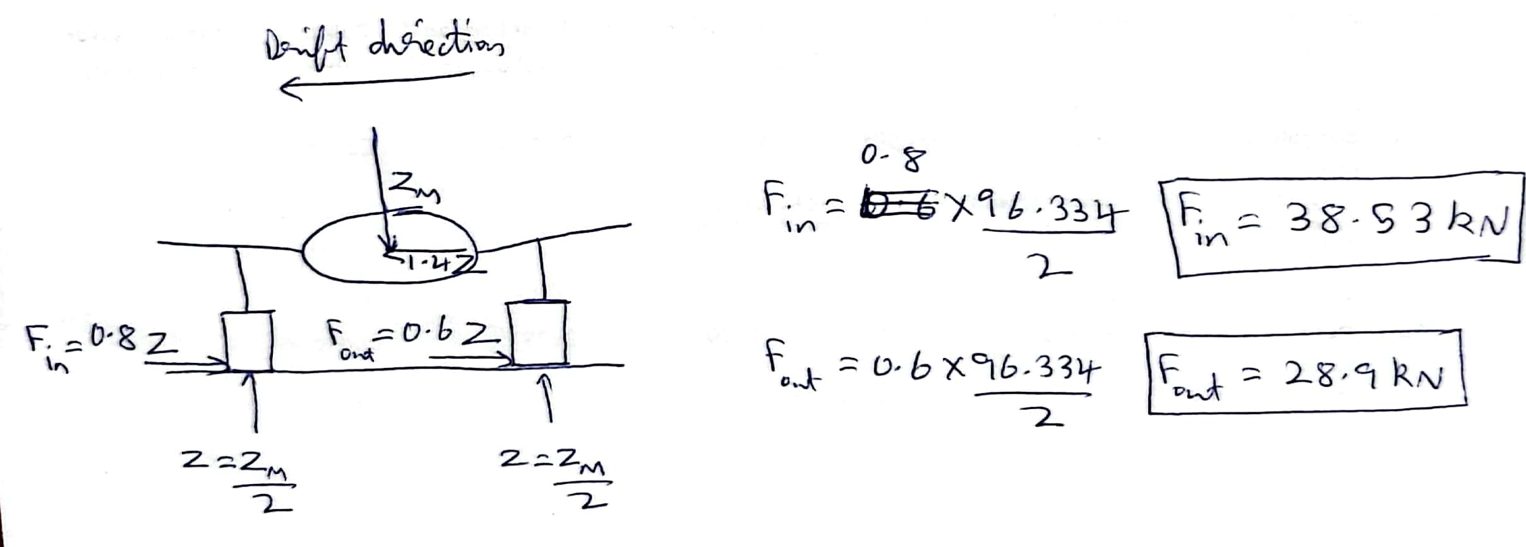

F_{in} = 38.53 kN
F_{out} = 28.9 kN

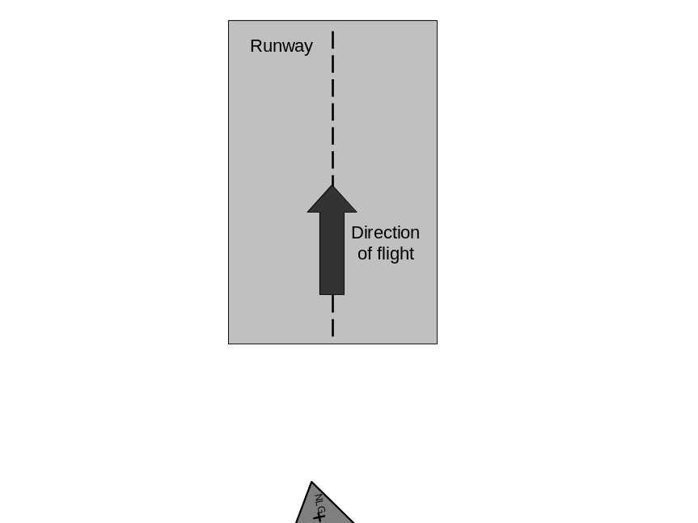

LEVEL, 3-point landing

6/ Determine the maximum vertical reaction on the NLG in level, 3-point landing condition.

The sizing energy to be absorbed was calculated in Ques – 2. The NLG also absorbs this load through the shock absorber and tire combination. The calculations are similar to those of MLG.

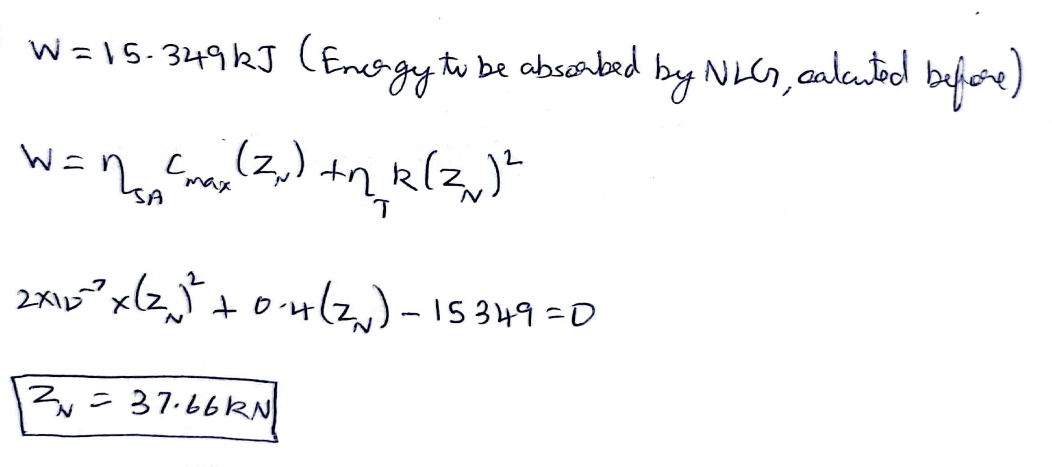

Z_{NLG}^{3-point} = 37.66 kN

BRAKE ROLL

7/ Determine the reaction on the NLG in brake roll condition. It is assumed that nose wheel is not equipped with brakes.

The MLG and NLG experience friction loads with friction coefficients with values of 0.8 and 0.25 respectively. This is because brakes are applied only on MLG which then experiences static friction while NLG continues to experience kinetic friction.

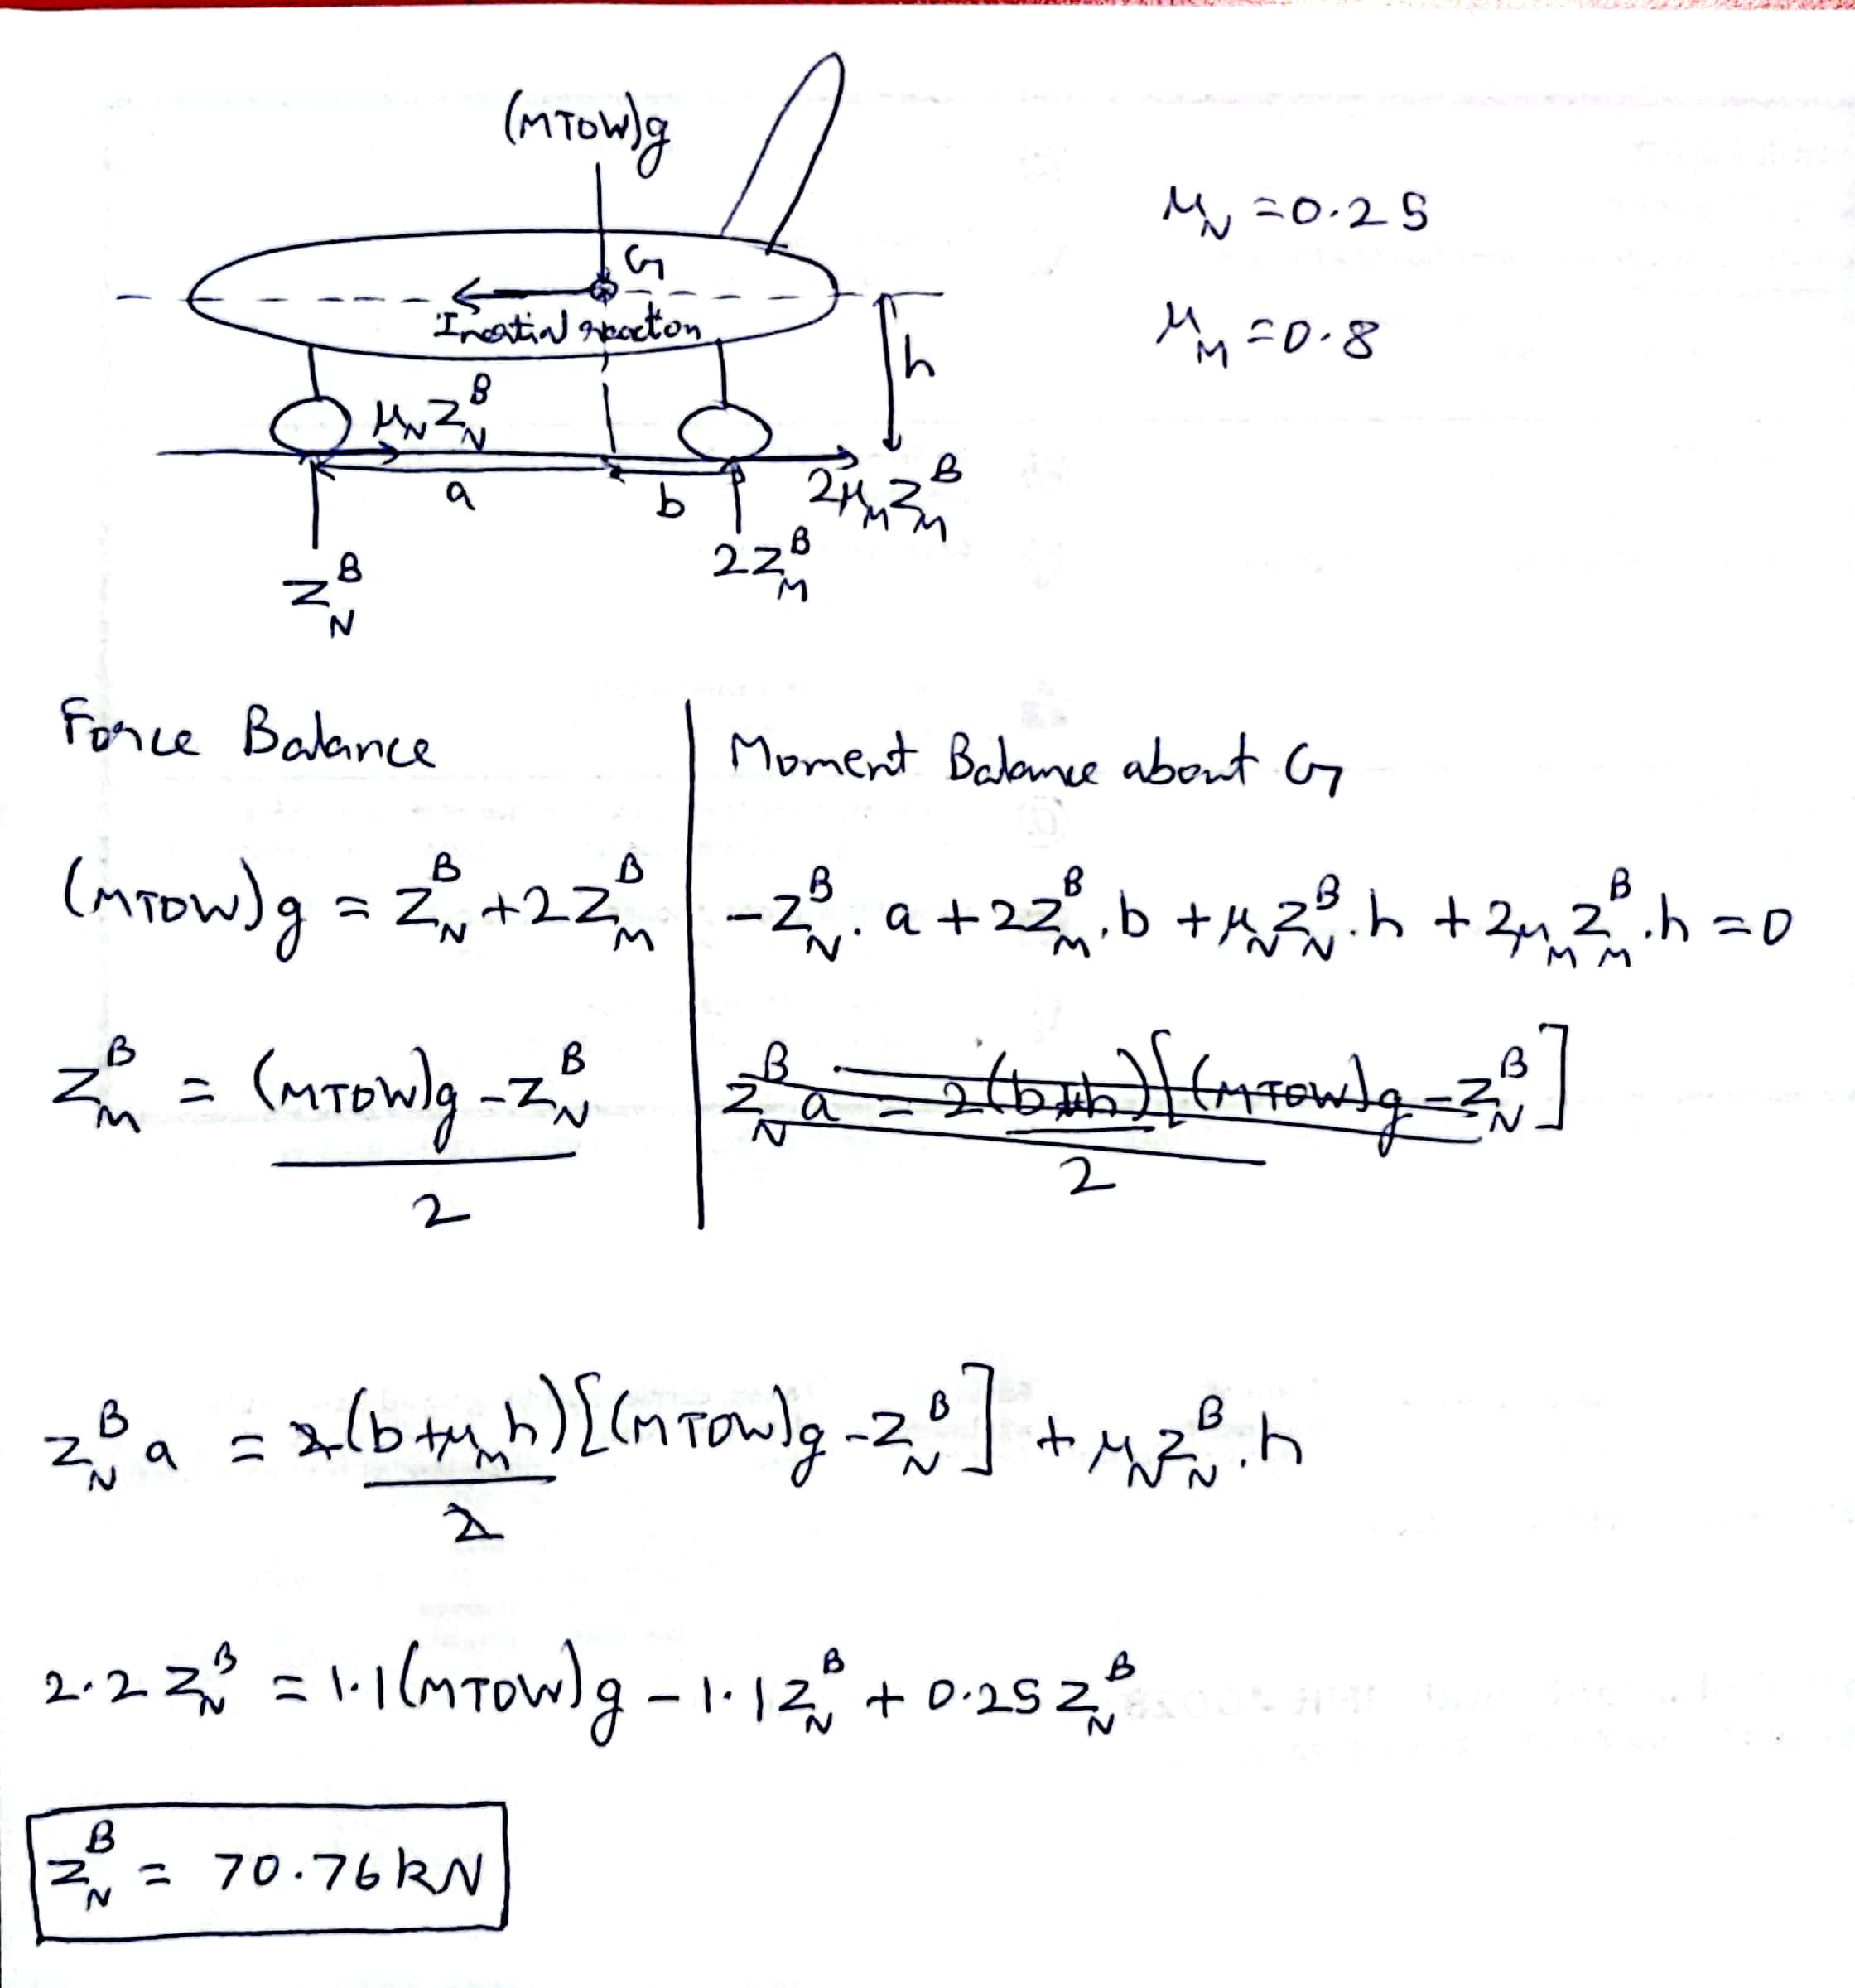

Z_{NLG}^{Braking} = 70.76 kN
TURNING

8/ Determine the reaction on the MLG and NLG in ground turning as defined in CS25.

Load is redistributed while the aircraft turns between the two MLGs, however, it does not change on the NLG. Depending on the direction of the turn, the outer landing gear experiences the higher load. Here, we consider the lateral centrifugal forces to be acting at half the maximum load. The loads on the MLGs are found through force and moment balances.

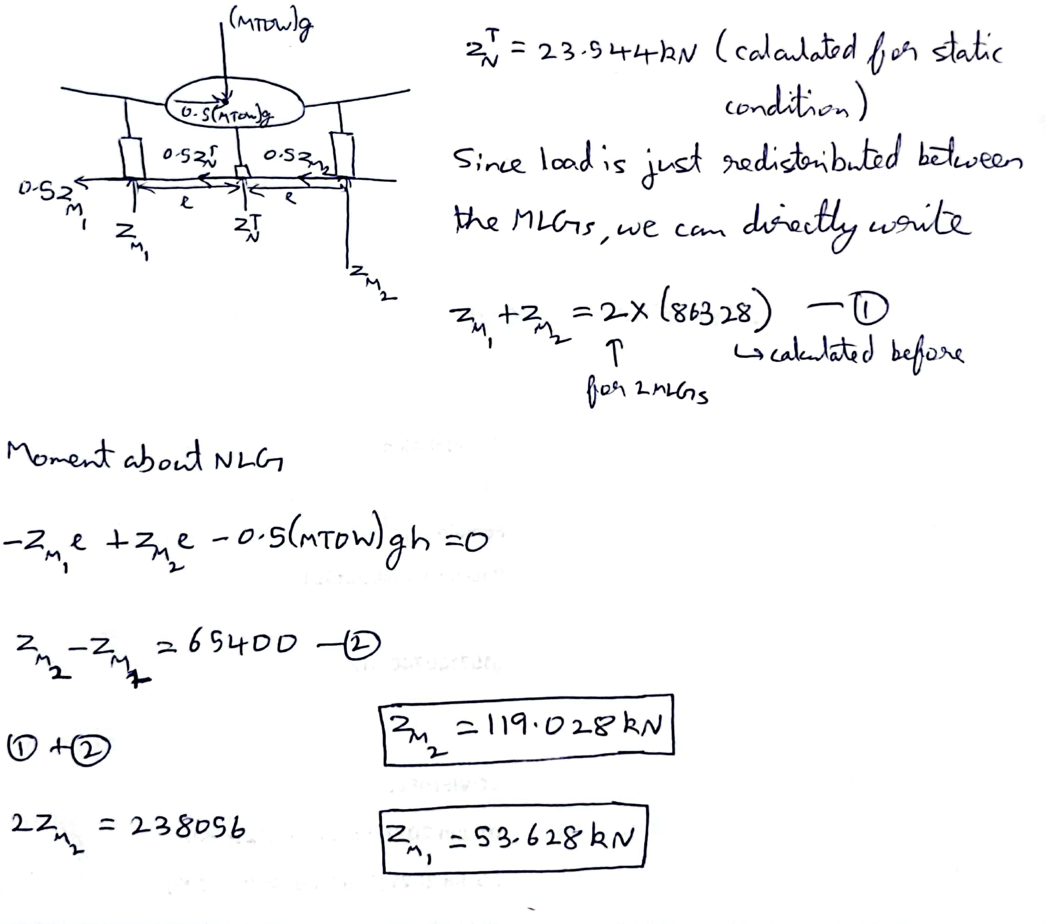

Z_{MLG1}^{Turning} = 119.028 kN
Z_{NLG1}^{Turning} = 53.628 kN

